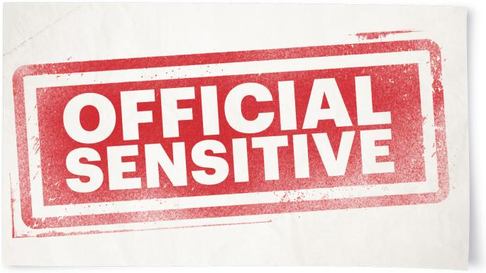
BASE SCENARIO
When the UK ceases to be a member of the European Union in October 2019, all rights and reciprocal arrangements with the EU end.
● The UK reverts fully to “third country” status. The relationship between the UK and the European Union as a whole is unsympathetic, with many member states (under pressure from the European Commission) unwilling to engage bilaterally and implementing protections unilaterally, though some member states may be more understanding.
● No bilateral deals have been concluded with individual member states, with the exception of the reciprocal agreement on social security co-ordination with the Republic of Ireland. EU citizens living in the UK can retain broadly all rights and status that they were entitled before the UK’s exit from the EU, at the point of exit.
● Public and business readiness for no-deal will remain at a low level, and will decrease to lower levels, because the absence of a clear decision on the form of EU Exit (customs union, no deal etc) does not provide a concrete situation for third parties to prepare for. Readiness will be further limited by increasing EU Exit fatigue caused by the second extension of article 50.
● Business readiness will not be uniform – in general large businesses that work across sectors are likely to have better developed counting plans than small and medium-size businesses. Business readiness will be compounded by seasonal effects and factors such as warehouse availability.
● Private sector companies’ behaviour will be governed by commercial considerations, unless they are influenced otherwise.
● Her Majesty’s government will act in accordance with the rule of law, including by identifying the powers it is using to take specific actions.
●Risks associated with autumn and winter, such as severe weather, flooding and seasonal flu, could exacerbate any effects and stretch the resources of partners and responders.
KEY PLANNING ASSUMPTIONS
Exit day
For the purpose of freight flow and traffic management, as October 31 is a Thursday, Day 1 of Exit is now on a Friday rather than the weekend, which is not to our advantage. Exit Day may coincide with the half-term holiday, which varies across the UK.
Member states
In a small number of instances where the impacts of Brexit would be felt negatively in the EU as well as in the UK, member states may act in a way that could benefit the UK.
Channel ports
France will impose EU mandatory controls on UK goods on Day 1 of No Deal and has built infrastructure and IT systems to manage and process customs declarations and to support a risk-based control regime. On Day 1 of No Deal, 50%-85% of HGVs travelling via the short straits may not be ready for French customs. The lack of trader readiness combined with limited space in French ports to hold “unready” HGVs could reduce the flow rate to 40%-60% of current levels within one day.
The worst disruption to the short Channel crossings might last 3 months before flow rates rise to about 50%-70% (as more traders get prepared), although disruption could continue much longer. In the event of serious disruption, the French might act to ensure some flow through the short Channel crossings.
Disruption to Channel flow would also cause significant queues in Kent and delays to HGVs attempting to use the routes to travel to France. In a reasonable worst-case scenario, HGVs could face a maximum delay of 1½-2½ days before being able to cross the border. HGVs caught up in congestion in the UK will be unable to return to the EU to collect another load and some logistics firms may decide to avoid the route. Analysis to date has suggested a low risk of significant sustained queues at ports outside Kent that have high volumes of EU traffic, but the Border Delivery Group will continue to work directly with stakeholders at those ports to support planning readiness.
Border checks
UK citizens travelling to and from the EU may be subject to increased immigration checks at border posts. This may lead to passenger delays at St Pancras, Cheriton (Channel tunnel) and Dover, where border controls are juxtaposed. Depending on what plans EU member states put in place to cope with these increased immigration checks, it is likely delays will occur for UK arrivals and departures at EU airports and ports. This could cause some disruption on transport services. Travellers may decide to use alternative routes to complete their journey.
Drugs and disease
i) The Border Delivery Group/Department for Transport planning assumption on reduced flow rates describes a pre-mitigation reasonable worst-case flow rate that could be as low as 40% on Day 1 of No Deal via the short straits [main Channel crossings], with significant disruption lasting up to six months. Unmitigated, this will have an impact on the supply of medicines and medical supplies.
Supply chains for medicines and medical products rely heavily on the short straits, which makes them particularly vulnerable to severe delays: three-quarters of medicines come via the short straits. Supply chains are also highly regulated and require transportation that meets strict Good Distribution Practices. This can include limits on transit times and temperature-controlled conditions. While some products can be stockpiled, others cannot because of short shelf lives. It will not be practical to stockpile six months’ supplies. The Department for Health and Social Care is developing a multi-layered approach to mitigate these risks.
ii) Any disruption that reduces, delays or stops the supply of medicines for UK veterinary use would reduce our ability to prevent and control disease outbreaks, with potential harm to animal health and welfare, the environment and wider food safety and availability, as well as, in the case of zoonotic diseases, posing a risk to human health. Industry stockpiling will not be able to match the 4-12 weeks’ stockpiling that took place in March 2019. Air freight capacity and the special import scheme are not a financially viable way to mitigate risks associated with veterinary medicine availability issues.
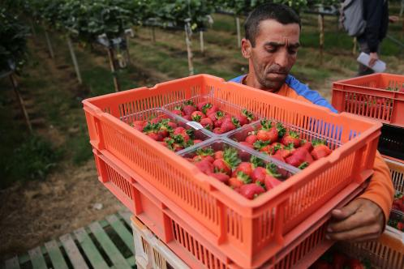
Food and water
i) Certain types of fresh food supply will decrease. Critical elements of the food supply chain (such as ingredients, chemicals and packaging) may be in short supply. In combination, these two factors will not cause an overall shortage of food in the UK but will reduce availability and choice and increase the price, which will affect vulnerable groups. The UK growing season will have come to an end, so the agri-food supply chain will be under increased pressure for food retailers. Government will not be able to fully anticipate all effects on the agri-food supply chain. There is a risk that panic buying will disrupt food supplies.
ii) Public water services are likely to remain largely unaffected, thanks to actions now being taken by water companies. The most significant single risk is a failure in the chemicals supply chain. The likelihood of this is considered low, and the impact is likely to be local, affecting only hundreds of thousands of people. Water companies are well prepared for any disruption: they have significant stocks of all critical chemicals, extensive monitoring of their chemicals supply chains (including transport and deliveries) and sharing agreements in place. In the event of a supply chain failure, or the need to respond rapidly to other water supply incidents, urgent action may need to be taken to make sure people continue to have access to clean water.
Law and order
Law enforcement data and information-sharing between the UK and the EU will be disrupted.
Financial services and insurance
Some cross-border UK financial services will be disrupted. A small minority of insurance payments from UK insurers into the EU may be delayed.
Data
The EU will not have made a data decision with regard to the UK before exit. This will disrupt the flow of personal data from the EU, where an alternative legal basis for transfer is not in place. In no-deal, an adequacy assessment could take years.
Fuel
Traffic disruption caused by border delays could affect fuel distribution in the local area, particularly if traffic queues In Kent block the Dartford crossing, which would disrupt fuel supply in London and the southeast. Customer behaviour could lead to shortages in other parts of the country.
Tariffs make UK petrol exports to the EU uncompetitive. Industry had plans to mitigate the impact on refinery margins and profitability, but UK government policy to set petrol import tariffs at 0% inadvertently undermines these plans. This leads to big financial losses and the closure of two refineries (which are converted to import terminals) with about 2,000 direct job losses. Resulting strike action at refineries would lead to disruptions to fuel availability for 1-2 weeks in the regions they directly supply. Government analysis of the impact of no-deal on refineries continues.
Northern Ireland
On Day 1 of No Deal, Her Majesty’s government will activate the “no new checks with limited exceptions” model announced on March 13, establishing a legislative framework and essential operations and system on the ground, to avoid an immediate risk of a return to a hard border on the UK side.
The model is likely to prove unsustainable because of economic, legal and biosecurity risks. With the UK becoming a “third [non-EU] country”, the automatic application of EU tariffs and regulatory requirements for goods entering Ireland will severely disrupt trade. The expectation is that some businesses will stop trading or relocate to avoid either paying tariffs that will make them uncompetitive or trading illegally; others will continue to trade but will experience higher costs that may be passed on to consumers. The agri-food sector will be hardest hit, given its reliance on complicated cross-border supply chains and the high tariff and non-tariff barriers to trade.
Disruption to key sectors and job losses are likely to result in protests and direct action with road blockades. Price and other differentials are likely to lead to the growth of the illegitimate economy. This will be particularly severe in border communities where criminal and dissident groups already operate with greater freedom. Given the tariff and non-tariff barriers to trade, there will be pressure to agree new arrangements to supersede the Day 1 model within days or weeks.
Energy supplies
Demand for energy will be met, and there will be no disruption to electricity or gas interconnectors. In Northern Ireland there will not be immediate disruption to electricity supply on Day 1. A rapid split of SEM could occur months or years after the EU Exit. In this event there would not be issues about security of supply. However, there will probably be marked price rises for electricity customers (business and domestic), with associated wider economic and political effects. Some participants could exit the market, exacerbating economic and political effects.
Gibraltar
Because of the imposition of checks at its border with Spain (and the knock-on effect of delays from the UK to the EU), Gibraltar will see disruption to the supply of goods (including food and medicines) and to shipments of waste, plus delays of four-plus hours for at least a few months in the movement of frontier workers, residents and tourists across the border.
Prolonged border delays over the longer term are likely to harm Gibraltar’s economy. As on the UK mainland, cross-border services and data flow will be disrupted. Despite the time extension to the UK’s exit from the EU, Gibraltar has still not taken the decisions to invest in contingency infrastructure (such as port adjustments and waste management equipment) and there are still concerns that Gibraltar will not have passed all necessary legislation for no-deal, opening up legal risks mainly for the government of Gibraltar. Gibraltar continues to plan for less significant border delays than in our Yellowhammer scenario. Crown dependencies may be affected by supply chain disruption.
Brits in Europe
i) UK nationals will lose their EU citizenship and can expect to lose associated rights and access to services over time, or be required to access them on a different basis. All member states have now published legislative proposals, but not all have passed legislation to secure all rights for UK nationals.
There is a mixed picture across member states in terms of the level of generosity and detail in the legislation. In some member states, UK nationals need to take action now. Complex administrative procedures within member states, language barriers and uncertainty regarding the UK political situation are contributing to some UK nationals being slow to take action. Demands for help on Her Majesty’s government will increase significantly, including an increase in consular inquiries and more complex and time-consuming consular assistance cases for vulnerable UK nationals.
Cross-government support, including continued close engagement and clear communications from UK government departments and the departmental agencies, will be needed to help manage the demand.
ii) An EU member state would continue to pay a pension it currently pays to a UK national living in the EU.
iii) The commission and individual member states do not agree to extend the current healthcare arrangements for UK state pensioners and tourists beyond October 31, 2019, and refuse offers by the UK to fund treatments. Member states take no further action to guarantee healthcare for UK nationals and treat them in the same way as the other “third country” nationals. UK pensioners, workers, travellers and students will need to access healthcare in different ways, depending on the country. Healthcare systems may require people to demonstrate residency and current or previous employment, to enter a social insurance scheme or to purchase private insurance. Member states should treat people with urgent needs but may require them to pay after the fact. There is a risk of disruption for patients, and a minority could face substantial costs.
Protests and police
Protests and counter-protests will take place across the UK, using up police resources. There may also be a rise in public disorder and community tensions.
Fishing
Up to 282 EU and European Economic Area nations’ fishing vessels could enter illegally or are already fishing in UK waters: up to 129 vessels in English waters, 100 in Scottish waters, 40 in Welsh waters and 13 in Northern Irish waters on Day 1. This is likely to cause anger and frustration in the UK catching sector, which could lead to clashes between fishing vessels and an increase in non-compliance in the domestic fleet.
Competing demands on UK government and maritime departmental agencies and their assets could put enforcement and response capabilities at risk, especially in the event of illegal fishing, border violations (smuggling and illegal migration) and any disorder or criminality arising as a result, eg violent disputes or blockading of ports.
The poor
Low-income groups will be disproportionately affected by rises in the price of food and fuel.
Social care
There is an assumption that there will be no big changes in adult social care on the day after EU Exit. The adult social care market is already fragile because of the declining financial viability of providers.
An increase in inflation after the UK’s EU exit would affect providers of adult social care through increasing staff and supply costs, and might lead to failure within 2-3 months for smaller providers and 4-6 months for larger ones. There are also local risks — transport or staff disruption, severe winter weather or flu — that could exacerbate existing market fragility and that cumulatively could stretch the resources of providers and local authorities.
Intelligence will continue to be gathered to prepare for any effects on the sector, including closure of services and handing-back of contracts that are not part of the normal market function. In addition, by mid-August we will look at the status of preparations in four local authorities identified as concerns.

